Requirements Specification

|  |  |
| --- | --- |
| **Client Details** |  |
| **Name**  Leona Beale |  |
| **Company**  Beales Shoes |  |
| **Contact**  [Leona.beale@ncirl.ie](mailto:Leona.beale@ncirl.ie) 01 4498778 |  |

|  |  |
| --- | --- |
| Technical specs |  |
| **Domain name**  Needs to be created – bealesshoes.ie |  |
| **Extensions required (.ie,.com etc)**  .ie .com .co.uk |  |
| **Contact form required?** Yes |  |
| **Email address(es) needed** needs to be created |  |
| **Will there be an online order/shopping facility?**  Yes |  |

# Site Map (Please edit sample below)

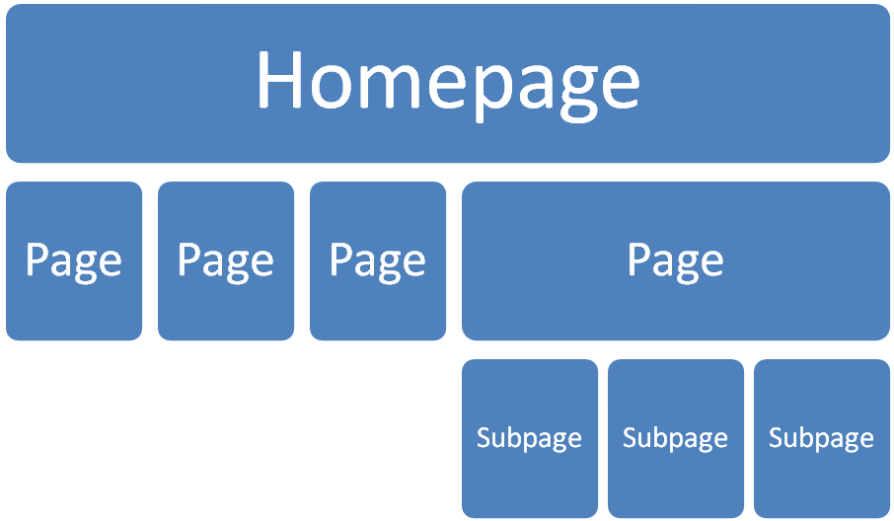

|  |
| --- |
| **Additional comments.** |
| **Do you have a company logo? If yes, please attach and send file.**  This is something that I would also like for you to create.  **Do you have any ideas or preferences around how your website will look?**  **Genres/ colour schemes/ etc?**  **If yes, please be as descriptive and specific as possible.**  Would like the site to be extremely visual and as interactive as possible  Would like a link to my LinkedIn [ie.linkedin.com/in/leonabeale/](http://ie.linkedin.com/in/leonabeale/" \o "View public profile)  Would like to be able to upload video links  Would like the colour scheme to incorporate shades of blue  Would like it to interact with other social media sites  **What catagories would you need – womens/mens/children//sale items/new trends/special?**  This would be mainly women’s footwear, latest trends from big designers  **Would you like product photos and descriptions displayed? If yes, please send the files or information for us to source them.**  **Latest designs from the following designers:**  Carl Scarpa  Dunne  Hunter  Jimmy Choo  [Christian Louboutin](http://en.wikipedia.org/wiki/Christian_Louboutin)  Marc Jacobs  Mulberry  Please feel free to add others  **Please add any other information that may help us to design your website?** |